HEIDENHAIN at SPS Italia 2024:
New products and more brands for smarter automation solutions

The HEIDENHAIN booth at SPS Italia 2024 is presenting two main topics: new products for highly-demanding automation technology, such as the ECI 123 Splus rotary encoder with built-in vibration analysis, and the assumption of sales activities for the LEINE LINDE and LTN brands at HEIDENHAIN ITALIANA. Also being presented from May 28 to 30 in Parma are motor and drive-system technology products from ETEL, special encoder solutions for robotics, the EnDat 3 interface for digital integration of encoders into machines and automated systems, and the large assortment of encoders from HEIDENHAIN, AMO, RENCO and RSF for automation technology.

Built-in vibration analysis:
The ECI 123 Dplus inductive rotary encoder
Detecting vibrations early on is vital for ensuring smooth processes, perfect results and long machine service life in high-performance production automation. The earlier the detection, the easier it is to prevent scrap, machine damage and system downtime. By integrating an accelerometer into a rotary encoder, HEIDENHAIN has created a new and convenient solution for detecting and analyzing vibrations on rotating machine elements: the ECI 123 Splus.

The ECI 123 Splus delivers position feedback and vibration analysis in a single device. Users benefit from combined motion control and condition monitoring on their rotating machine elements. Linking vibration data with position feedback has another advantage: it’s easier to determine the type and location of the vibration’s source. And for even more data, the ECI 123 Splus supports up to three connected external temperature sensors.

The ECI 123 Splus therefore supports customized online condition monitoring for early fault detection and precise analysis. As a result, machine users can leverage predictive maintenance to optimize machine servicing intervals based on actual wear and adjust their production schedules in advance for irregular maintenance. And when all this data is collected over a longer period, users can realistically estimate a machine’s remaining service life.

How does all this data make it to the downstream electronics? Thanks to the encoder’s EnDat 3 interface. This combined functionality saves on additional vibration sensors while simplifying cabling and installation.

More brands, more options:
LEINE LINDE and LTN now from HEIDENHAIN ITALIANA
SPS Italia will mark the first time that HEIDENHAIN ITALIANA presents the LEINE LINDE and LTN brands. LEINE LINDE and LTN have been part of the HEIDENHAIN Corporate Group for many years. By integrating these brands into the local HEIDENHAIN sales organization, current and new customers in Italy now have direct access to the extensive product portfolio of eight brands: HEIDENHAIN, AMO, ETEL, LEINE LINDE, LTN, NUMERIK JENA, RENCO and RSF.

LEINE LINDE specializes in rotary encoders and sensors that provide exact position measurement over long periods and with great reliability in harsh environments. Typical application areas include steel mills, wind turbines, shipbuilding and other offshore applications, along with cranes, construction machines and the paper industry.

LTN offers slip rings and resolvers as part of its extensive standard product portfolio and also as customized solutions. Their applications range from the machine-tool industry and industrial automation, including packaging machines, to medical technology, aircraft manufacturing and photovoltaic systems.

EnDat 3: Digitally integrate your encoders
Proven, consistently developed, and ready for the future of digitalization: meet the EnDat interface from HEIDENHAIN. Secure integration of encoders into systems is easy with EnDat. HEIDENHAIN will demonstrate bus operation with the EnDat 3 interface using three different encoders. EnDat 3 transmits the position, sensor and monitoring data via only four wires at a cycle time of 30 µs. HEIDENHAIN will also use a measuring arm to demonstrate how the encoders on all joints transmit their position data via EnDat 3 in bus operation. The benefits are reduced cabling, functional safety capability, and extensive diagnostics. This makes EnDat 3 the ideal encoder interface for achieving high system integration and meeting the requirements of future digitalization, with system cost savings and a versatile machine architecture.

Inductive rotary encoders for motion control:
Intelligent encoders from HEIDENHAIN set new standards in robotics
The KCI 120 Dplus dual encoder from HEIDENHAIN combines motor feedback and position measurement in one encoder. By measuring the axis position downstream from the gearbox, the encoder compensates for inaccuracies inherent in highly articulated and dynamic robots. To achieve this dual functionality, the encoder employs a single scanning unit and two separate, inductively scanned circular scales. To ensure maximum versatility, the KCI 120 Dplus is now available in three versions. The central scanning unit and two separate disk/hub assemblies are thus suited for various hollow-shaft diameters and installation dimensions. The KCI 120 Dplus from HEIDENHAIN offers compact form factors and easy integration combined with consistent functionality.

HEIDENHAIN developed the KCI 1319 (singleturn) and KBI 1335 (multiturn) inductive rotary encoders specifically for compact motors in robots and other automation applications. Along with the scanning head, they are available with a screw-on circular scale or a press-fit disk/hub assembly. This is possible thanks to their 25-mm hollow shaft, very flat design and low weight. They are also immune to contamination and magnetic fields.

Also available are the KCI 1318 FOT and KBI 1335 FOT. Thanks to fan-out technology (FOT), HEIDENHAIN was able to merge the electronic components and conductive tracks directly with a metal carrier. This carrier can be used as a bearing cover, for example. Not only does this reduce the space required and the necessary number of parts, but it also enables direct outward heat dissipation through the metal carrier.

The KCI 120 and KBI 136 compact rotary encoders for large hollow shafts with diameters of 30 mm or 40 mm round out the portfolio of inductive rotary encoders from HEIDENHAIN for robotics applications. They convey the strengths of the smaller 1300 series to significantly more sturdy and powerful robot motors.

Greater performance for compact motors in demanding automation applications:
The next generation of inductive scanning from HEIDENHAIN
The ECI 1122 and EQI 1134 are the first rotary encoders to employ the next generation of inductive scanning from HEIDENHAIN. They feature low noise, low speed ripple and extensive operating data. And thanks to their EnDat 3 interface, they can be connected using the HMC 2 single-cable solution. Their many benefits make them uniquely attractive position feedback solutions for compact motors in demanding automation applications.

At the heart of the ECI 1122 and EQI 1134 encoders and their inductive scanning technology is a new HEIDENHAIN ASIC with 180-nanometer technology, providing the perfect combination of reliability, robustness and miniaturization in industrial applications. Another highlight and a completely new approach for a sensor ASIC is the application-specific integrated processor (ASIP). The ASIP allows motor and encoder operating data to be collected to a much greater extent, right at the motor. This operating data, including loads, operating times and motor temperatures, provides a solid basis for optimizing operation, maximizing service life, streamlining maintenance, and more. It’s the key to condition monitoring and predictive maintenance.

Expanding into automation applications with the ECI 1122 and EQI 1134 inductive encoders required, above all, boosting their singleturn position resolution to 22 bits. This higher resolution strongly mitigates a motor’s speed ripple and position noise. Thanks to features like this, these rotary encoders meet current automation challenges head-on, including demand for ever higher accuracy, performance, process reliability and cost efficiency.

And, for the first time, this next generation of inductive rotary encoders implements EnDat 3 directly on a scanning ASIC. This single-chip solution enables use of the HMC 2 single-cable solution, which combines power and data wires in a single cable. Along with its high data rates, HMC 2 reduces cabling and space needs. These rotary encoders also offer various other serial interfaces in addition to EnDat 3.

Modular angle measuring systems from AMO and RSF:
Secondary encoders for wide-shaft robotics motors
Robot manufacturers can significantly improve absolute position accuracy by including additional highly accurate angle encoders on each robot axis. Mounted downstream from the gear system, secondary encoders measure the actual position of each robot joint. Modular solutions, such as the WMRA angle measuring system from AMO or the new MCR 16 angle encoder from RSF, are also available for this type of application. Thanks to their modular design with a scale drum or measuring ring and a separate scanning unit, they are ideal for large shaft diameters but also for difficult installation situations. The inductive secondary encoder solutions from AMO are characterized by increased robustness and are highly versatile in their physical design. The MCR 16 from RSF delivers optical scanning with improved signal quality for absolute position measurement on axes with large diameters.

RTMB+, TUCANA ST and AQUARIUS ST from ETEL:
More possibilities for test handling in the chip industry
Even though miniaturization is the main driving force in R&D for the semiconductor and electronics industry, packaging and inspection procedures must also be able to handle ever larger components under maximum performance and process reliability. It is exactly for these applications that the RTMB+ indexing tables from ETEL offer a high load capacity paired with high speeds. When equipped with the TUCANA ST and AQUARIUS ST short stroke actuators, the test handlers do not apply any loads to the chips and wafers during packaging and inspection.

RENCO R35i and R35iL: The compact rotary encoders for stepper motors and BLDC motors
The RENCO R35i and R35iL rotary encoders ensure high throughput and reliable operation in the lab automation and liquid handling fields. These incremental, bearingless encoders enable fast and accurate stepper and BLDC motor positioning on, for example, the many axes and belts used in blood-testing machines. With 40 000 measuring steps per revolution, they are the ideal motor feedback solution for these applications. If an encoder is needed for the cramped installation spaces of dialysis machines, blood pumps and metering pumps, then the RENCO R35iL encoder is the right choice. It features a height of just 8.6 mm, making it one of the flattest rotary encoders currently on the market. Both the R35iL and R35i include an integrated self-centering mechanism for fast and precise alignment on the motor shaft, making installation easy even under challenging conditions. After installation, you can use the PWT 101 testing device and its integrated traffic-light mounting assistant to check for proper installation.

HEIDENHAIN at SPS Italia from May 28 to 30, 2024: Hall 3, Booth D040

For more information, visit:
sps.heidenhain.com
www.heidenhain.com

Contact persons for the trade press:  Frank Muthmann  DR. JOHANNES HEIDENHAIN GmbH  Dr.-Johannes-Heidenhain-Straße 5  83301 Traunreut, GERMANY  Tel.: +49 8669 31-2188  muthmann@heidenhain.de | Ulrich Poestgens  DR. JOHANNES HEIDENHAIN GmbH  Dr.-Johannes-Heidenhain-Straße 5  83301 Traunreut, GERMANY  Tel.: +49 8669 31-4154  poestgens@heidenhain.de

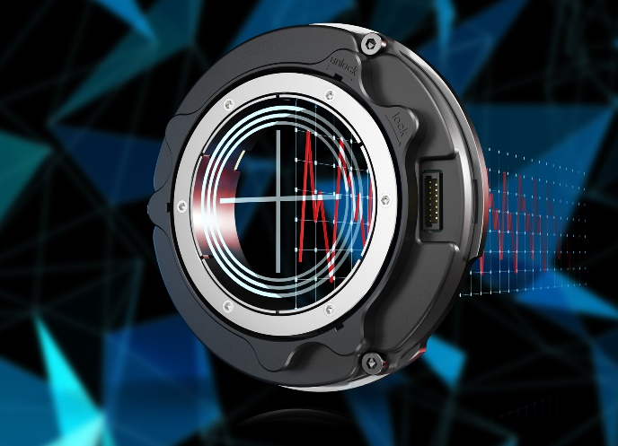 | The HEIDENHAIN ECI 123 Splus: Featuring a built-in accelerometer, this inductive rotary encoder enables position measurement and vibration analysis in a single automation component.
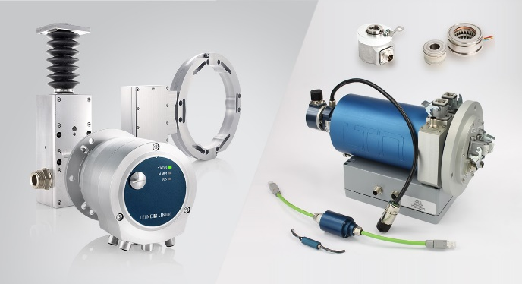 | Effective immediately, LEINE LINDE rotary encoders and sensors for harsh environments, as well as LTN slip rings and resolvers, are included in the product portfolio of HEIDENHAIN ITALIANA.
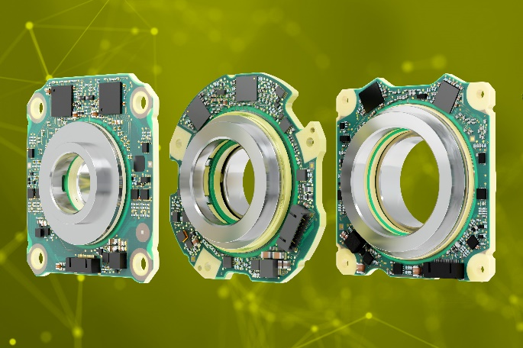 | The three versions of the KCI 120 Dplus dual encoder from HEIDENHAIN combine motor feedback and position measurement in just one rotary encoder, making it ideal for advanced robotics applications.
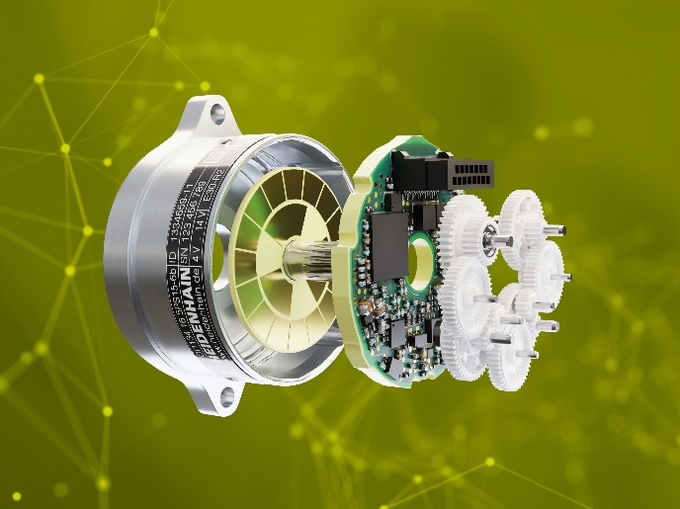 | A detailed look at the HEIDENHAIN EQI 1134 multiturn variant: The new ASIC incorporates position generation, functional safety for SIL 3 monitoring, an on-chip temperature sensor and a data management processor.

